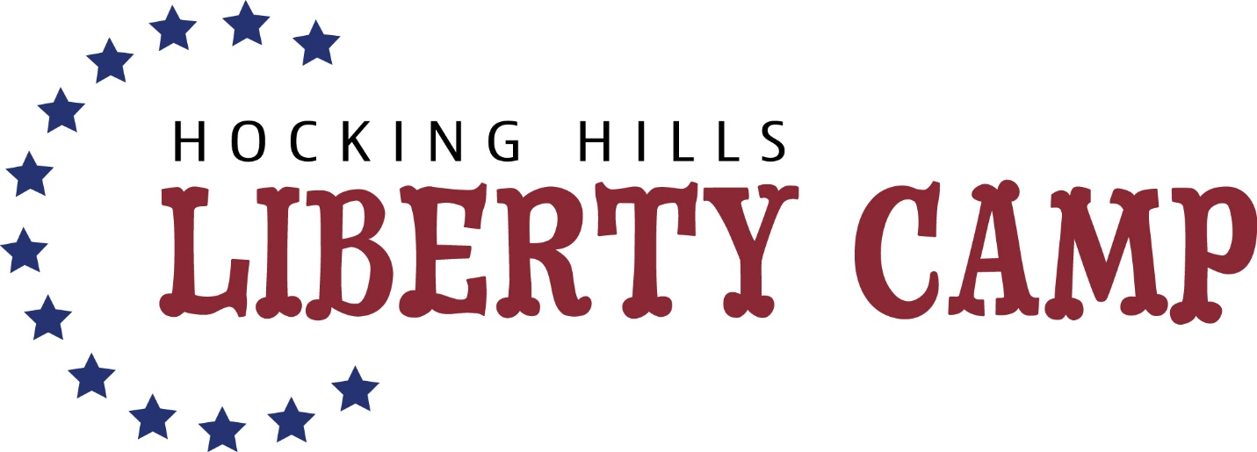

Authorization for child(ren) pick-up other than a parent/guardian

I, ______________________________________________(parent name) give permission for my child(ren)______________________________________________________________to be picked up from the 2023 Hocking Hills Liberty Camp at Cornerstone Baptist Church by the following people.
Name of Adult | Relationship to Child(ren) | Phone Number

Signed:______________________________________________________
Date:___________________________________________
Please give the authorized people listed above a code word and we will ask upon pick up before signing out.
Code word:____________________________________________________

