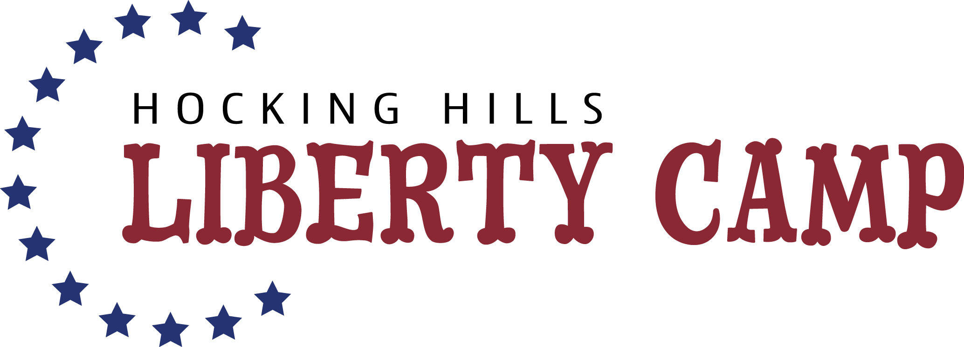

Waiver of Liability

This agreement releases Liberty Camp and facilities used from all liability relating to injuries that may occur during conduct of Liberty Camp. By signing this agreement, I agree to hold Liberty Camp entirely free from any liability, including financial responsibility for injuries incurred, regardless of whether injuries are caused by negligence.

I also acknowledge the risks involved in the instructional camp. These include but are not limited to personal injury, food related problems. I swear that I am participating voluntarily, and that all risks have been made clear to me. Additionally, I do not have any conditions that will increase my likelihood of experiencing injuries while engaging in the activity.

By signing below I forfeit all rights to bring a suit against Liberty Camp or facility owners where camp is held for any reason. In return, I will receive six half-days of Liberty Camp. I will also make every effort to obey safety precautions as listed in writing and as explained to me verbally. I will ask for clarifications when needed.

I, _________________________________, fully understand and agree to the above terms.

______________________________________________________________ _______________________________
(Signature of Parent or Legal Guardian) (Date)

