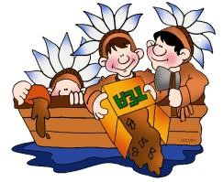 LIBERTY CAMP 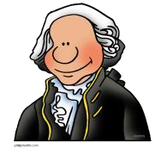
For Kids!

An American History interactive camp for ages 8 – 12

Dates: July 25 – July 30, 2022

Highlights of the Camp

- God’s role in the creation of our beloved country.
- Each day we will explore a different theme. On Monday, our theme is “Colonial Life.” We will learn about the first settlers in the new American land and what life was like for them. On Tuesday, we will look at the events leading to the Revolution, such as the Boston Tea Party, the Boston Massacre, Paul Revere’s ride, and the Declaration of Independence. On Wednesday and Thursday, we learn about the Revolutionary War from members of the Hocking Valley Chapter, Sons of the American Revolution and a group of re-enacters from the Brigade of the American Revolution, 8th Pennsylvania Regiment. Friday’s theme is the American View of government. We will explore our Constitution, the Bill of Rights, and learn the difference between a republic and a democracy. Do you know whether the United States is a democracy or a republic? Do you know the difference and why it is important?
- Saturday is Family Day at Camp. We will have a potluck picnic and present campers with their certificates and awards. Campers will have an opportunity to visit the Liberty Store. Other special presentations are planned for families to learn together. AND we close camp with a very special appearance of the Heritage Fifes & Drums.
- The camp is an interactive camp, with many activities each day and throughout the week. Activities and topics may change from year to year, as we bring new topics of interest to the camp. However, some activities may include dressing as the Sons of Liberty to re-enact the Boston Tea Party, experiencing what it feels like to march though ice and snow with only rags wrapped on feet, grinding corn and making butter, and signing your own Declaration of Independence with a quill pen.
- Throughout the week, we will be visited by various characters from our history.
- Each day, we will learn about our flag, our national anthem, and other symbols unique to America.

Where is it held? Cornerstone Baptist Church, 15024 SR 328 Logan Ohio 43138

What is the cost? Liberty Camp is offered for $25 per child, $15 per additional child in the family.
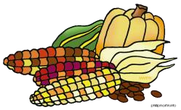
When is it held? July 25 – 29 from 6 – 9 PM and concludes with Family Day on Saturday July 30, from 10 -2. Please register online at www.3elearningenterprises.com.

