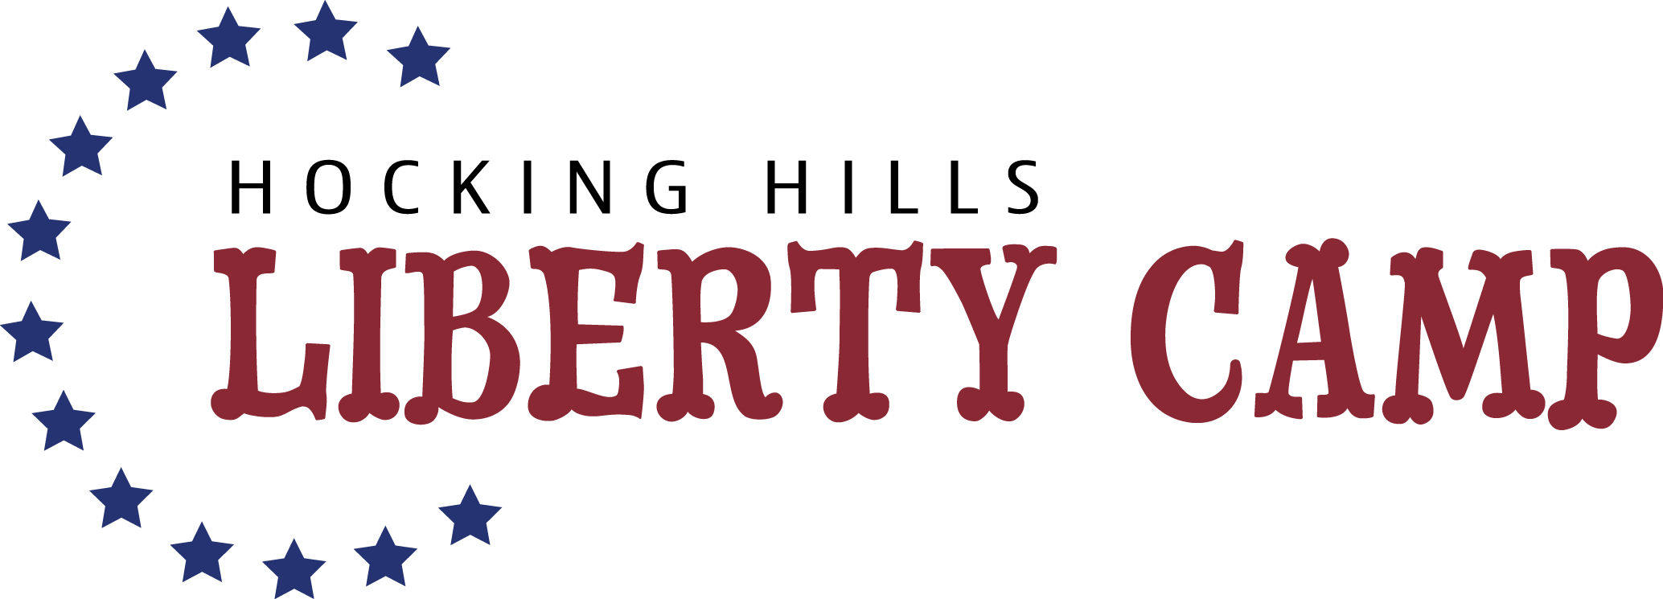

Photo Release Form
Liberty Camp/3E Learning Enterprises
Logan, Ohio

Permission to Use Photograph

Event: 2021 Liberty Camp
Location: Cornerstone Baptist Church, Logan, Ohio

I grant to the 3E Learning Enterprises group conducting the Liberty Camp, the right to take photographs of me and my family in connection with the above-identified event. I authorize the above group, its assignees and transferees to copyright, use and publish the same in print and/or electronically.

I agree that said organization/group may use such photographs of me or my family with or without my name and for any lawful purpose, including for example such purposes as publicity, illustration, advertising, and Web content.

I have read and understand the above:

Signature ___________________________________________________

Printed Name _______________________________________________

Address ____________________________________________________

Date _______________________________

_____________________________________________________________
Signature of Parent/Guardian

