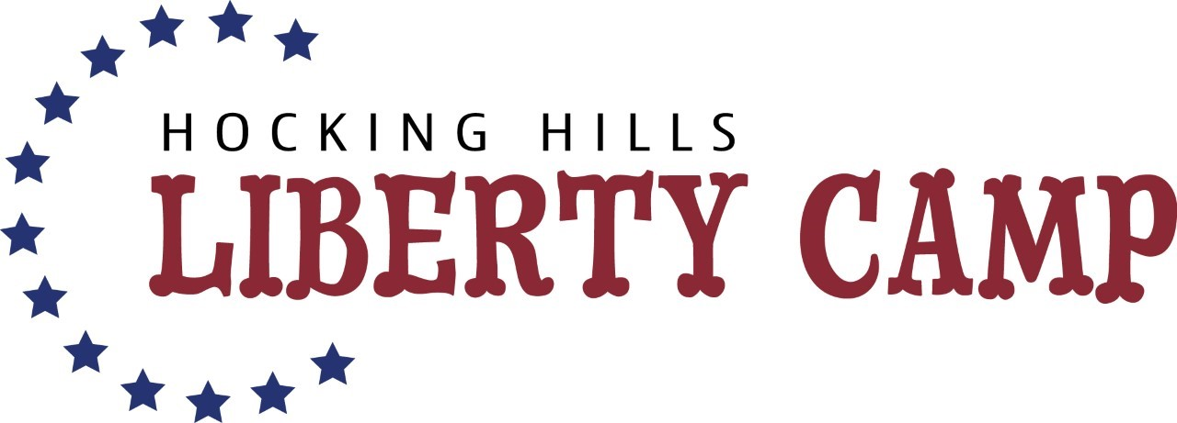

Picnic Potluck RSVP

Saturday, July 31, 2021, 10am-2pm

Name _______________________________________________

___Yes, we are coming to the Picnic/Potluck and there are

_________ in our family.
(number)

We plan to bring the following dish(es)

_________________________________________

_________________________________________

** Please label any food that contains peanuts or peanut products.

Note: Meat and Table service will be provided.

